Swiggy Data Analysis Dashboard

Comprehensive Business Intelligence Report
Prepared by: Tamer Elkot
Date: [22/11/2025]
Project Duration: [18/11/2025] - [22/11/2025]

Table of Contents
- Executive Summary
- Project Overview & Objectives
- Business Requirements Document
- Data Dictionary & Methodology
- Technical Implementation
- Detailed Analysis & Findings
- Interactive Dashboard Features
- Strategic Recommendations
- Business Impact & ROI
- Technical Specifications
- Conclusion & Future Enhancements
- Appendix

1. Executive Summary
Project Impact
This comprehensive data analysis of Swiggy's operations uncovered critical business insights from ₹53.01 million in sales revenue across 197,430 orders. The project identified significant seasonal patterns, regional performance variations, and customer preference trends that can drive strategic business decisions.
Key Discoveries
- 33% revenue dip in Q3 requiring immediate seasonal strategy
- Vegetarian dishes generate 64.5% of total revenue (2:1 ratio vs Non-Veg)
- Bengaluru leads as top revenue-generating city
- Weekend-driven business with Tuesday showing lowest performance
Business Value
The interactive Excel dashboard enables Swiggy to monitor real-time performance, optimize resource allocation, and implement data-driven strategies for revenue growth and operational efficiency.

2. Project Overview & Objectives
Business Context
Swiggy, as a leading food delivery platform, requires continuous performance monitoring across multiple dimensions to maintain competitive advantage and drive growth.
Primary Objectives
- Analyze sales performance across temporal and geographical dimensions
- Understand customer preferences and satisfaction levels
- Identify seasonal patterns and operational bottlenecks
- Provide actionable insights for strategic decision-making
Scope of Analysis
- Time Period: January 2025 - August 2025
- Geographical Coverage: Multiple Indian states and cities
- Data Points: 197,430 orders with 14 analytical dimensions
- Revenue Scope: ₹53.01 million total sales

3. Business Requirements Document
3.1 Problem Statement
Create a comprehensive monitoring system to track Swiggy's business performance across key metrics and provide actionable insights for growth optimization.
3.2 Key Performance Indicators (KPIs)
KPI | Description | Business Purpose
Total Sales Revenue | Overall revenue from food orders | Financial performance tracking
Average Rating | Customer satisfaction score | Service quality measurement
Average Order Value | Revenue per transaction | Customer spending behavior
Rating Count | Total customer reviews | Engagement level assessment
Total Orders | Number of food orders | Operational volume tracking

3.3 Visualization Requirements
- Monthly Sales Trend - Identify seasonal patterns
- Daily Sales Pattern - Optimize daily operations
- Food Type Analysis - Menu optimization strategy
- Geographical Heat Map - Regional resource allocation
- Quarterly Performance - Strategic planning cycles
- Top Cities Ranking - Market focus prioritization

4. Data Dictionary & Methodology
4.1 Complete Data Dictionary
Original Dataset Structure
Field | Type | Description | Sample Values
State | Text | Delivery state | Karnataka, Delhi, Gujarat
City | Text | Delivery city | Bengaluru, Mumbai, Delhi
Order Date | Date | Order placement date | 6/29/2025, 4/3/2025
Restaurant Name | Text | Vendor name | Srinidhi Sagar Deluxe
Location | Text | Area within city | Kengeri, Rajarajeshwari Nagar
Category | Text | Menu category | Snack, Recommended, North Indian Gravy
Dish Name | Text | Food item name | Butter Murukku, Badam Milk
Price (INR) | Numeric | Item price | 133.9, 52, 117
Rating | Numeric | Customer rating (1-5) | 4.0, 4.5, 4.7
Rating Count | Numeric | Number of ratings | 0, 25, 48
Derived Analytical Fields
Field | Creation Method | Business Purpose
Food Type | Text analysis from Dish Name | Dietary preference analysis
Day | =TEXT(Order_Date, "ddd") | Daily pattern analysis
Quarter | ="Q"&ROUNDUP(MONTH()/3,0) | Seasonal performance
Week | =WEEKNUM(Order_Date) | Weekly trend monitoring
AOV | Total Revenue/Total Orders | Customer value analysis

4.2 Data Processing Methodology
Data Cleaning Steps
- Duplicate Removal - Ensured data integrity by removing identical records
- Data Validation - Verified price ranges, rating scales, and date formats
- Text Standardization - Consistent naming conventions for restaurants and locations
- Food Type Classification - Systematic categorization of Veg/Non-Veg items
Feature Engineering
- Temporal Features: Extracted multiple time dimensions for trend analysis
- Categorical Grouping: Created business-relevant categories for segmentation
- Calculated Metrics: Developed derived KPIs for comprehensive analysis

5. Technical Implementation
5.1 Tools & Technologies
- Microsoft Excel: Primary analysis platform
- Pivot Tables & Power Pivot: Data aggregation and analysis
- Advanced Charts: Data visualization and trend representation
- Slicers & Timelines: Interactive dashboard controls
- Conditional Formatting: Visual performance indicators
5.2 Excel Features Utilized
- Pivot Tables for multi-dimensional analysis
- Pivot Charts for visual representation
- Slicers for interactive filtering
- Timeline Controls for date range selection
- Conditional Formatting for performance highlighting
5.3 Dashboard Architecture
text
Raw Data → Data Cleaning → Feature Engineering → Pivot Tables →
Interactive Charts → Dashboard Assembly → Slicer Integration →
Final Review & Testing

6. Detailed Analysis & Findings
6.1 Financial Performance Overview
Metric | Value | Business Implication
Total Revenue | ₹53.01M | Strong market presence
Total Orders | 197.43K | High customer engagement
Average Order Value | ₹268.51K | Premium customer base
Customer Ratings | 5.59M | Excellent user engagement
Average Rating | 4.34/5 | High service quality

6.2 Monthly Performance Analysis
Revenue by Month
January: ₹6.83M 🥇 (Peak Performance)
August: ₹6.79M 🥈 (Strong End)
May: ₹6.79M 🥈 (Consistent Performer)
April: ₹6.59M
March: ₹6.57M
July: ₹6.65M
June: ₹6.51M
February: ₹6.27M 🥉 (Needs Improvement)
Key Insight: Post-holiday dip in February followed by recovery, with strong performance in beginning and end months.
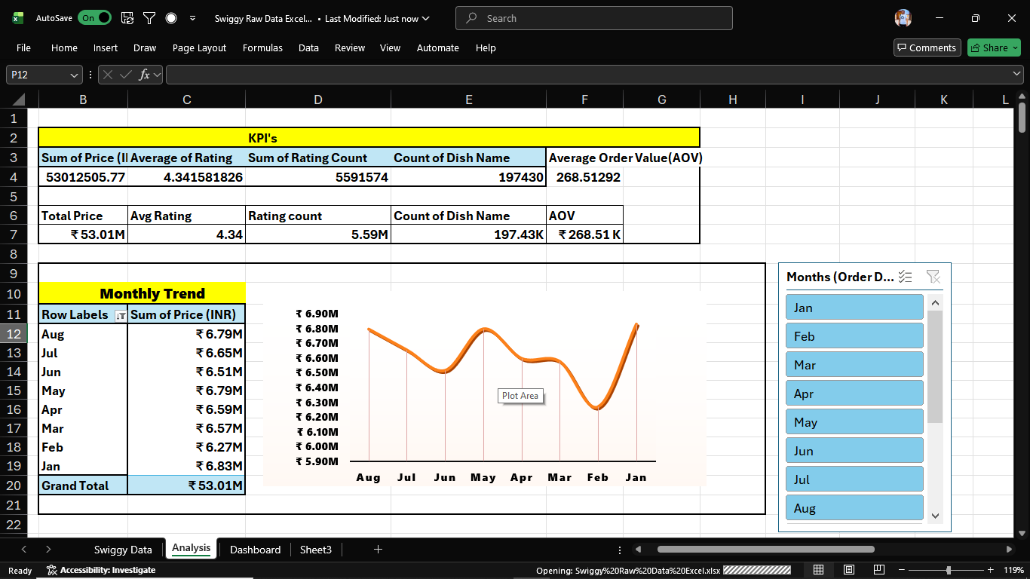

6.3 Quarterly Performance Breakdown
Revenue Distribution
Q2: ₹19.9M (37.5%) 🥇 BEST
Q1: ₹19.7M (37.2%) 🥈 EXCELLENT
Q3: ₹13.4M (25.3%) 🥉 CRITICAL AREA
Critical Finding: Q3 shows 33% decrease from Q2 peak, representing significant seasonal impact requiring immediate attention.

6.4 Daily Sales Patterns
Performance by Day
text
Saturday: 🥇 PEAK
Sunday: 🥈 STRONG
Thursday: 🥈 STRONG
Friday: MEDIUM
Wednesday: MEDIUM
Monday: LOW
Tuesday: 🥉 LOWEST
Business Implication: Clear weekend-driven pattern with mid-week operational optimization opportunities.
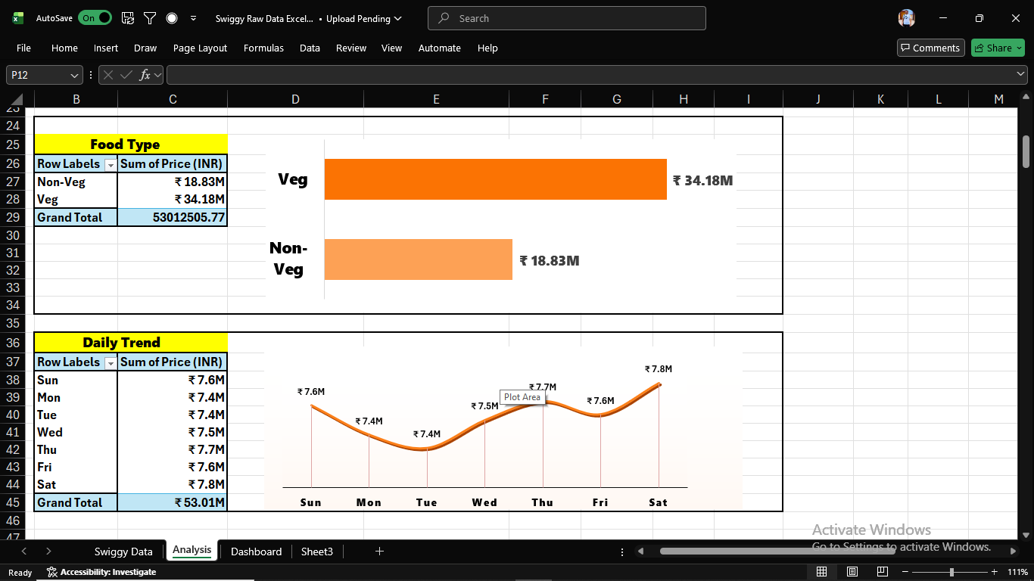

6.5 Product Category Analysis
Food Type Revenue Split
text
Vegetarian: ₹34.18M (64.5%) 🥇 DOMINANT
Non-Vegetarian: ₹18.83M (35.5%) 🥈 SIGNIFICANT
Strategic Insight: Vegetarian category generates nearly double the revenue of non-vegetarian options, indicating market preference and growth opportunity.



6.6 Geographical Performance
Top Performing States
- Gujarat: ₹2.8M 🥇
- Delhi: ₹2.8M 🥇
- Goa: ₹1.5M 🥈
- Haryana: ₹1.4M 🥈
- Himachal Pradesh: ₹1.4M 🥈
City Performance Ranking
- Bengaluru
- lucknow
- Mumbai
- Hyderabad
- Chandigarh

7. Interactive Dashboard Features
7.1 Dashboard Components
KPI Summary Section
- Real-time metric cards with conditional formatting
- Percentage changes and trend indicators
- Color-coded performance status
Visual Analytics Section
- Monthly Trend Line Chart: Seasonal pattern visualization
- Quarterly Performance Bars: Quarter-over-quarter comparison
- Daily Pattern Chart: Day-of-week analysis
- Geographical Heat Map: State-wise performance
- Food Type Pie Chart: Category contribution
- Top Cities Ranking: Horizontal bar chart
7.2 Interactive Controls
Filtering Capabilities
- Time Slicers: Monthly, quarterly, custom date ranges
- Geographical Filters: State, city, location-level filtering
- Category Filters: Restaurant type, food category, price range
- Performance Filters: Rating ranges, popularity filters
User Experience Features
- One-click filter reset functionality
- Linked slicers for coordinated views
- Tooltip information for detailed insights
- Responsive layout for different screen sizes

8. Strategic Recommendations
8.1 Immediate Actions (0-3 Months)
Q3 Performance Recovery
- Pre-Monsoon Campaigns (June)
  - Launch "Early Monsoon Offers" in last week of June
  - Partner with comfort food specialty restaurants
  - Implement targeted push notifications
- Tuesday Revenue Optimization
  - "Tuesday Treats": 25% discount on select categories
  - Corporate Partnership Program for office lunches
  - Subscription model for regular Tuesday customers
Vegetarian Category Enhancement
- Feature "Vegetarian Specials" on homepage
- Collaborate with premium vegetarian restaurants
- Create combo meals targeting family orders
8.2 Medium-term Strategies (3-6 Months)
Geographical Expansion
- Top Market Consolidation
  - Increase restaurant partnerships in Gujarat and Delhi
  - Enhanced delivery infrastructure in peak areas
  - Localized marketing campaigns
- Underperforming Market Development
  - Investigate Q3 dip causes in specific regions
  - Implement region-specific menu recommendations
  - Competitive analysis in low-performance areas
Operational Efficiency
- Resource Allocation: Align delivery staff with daily patterns
- Inventory Management: Predict demand using weekly trends
- Peak Hour Optimization: Enhance capacity during weekend rushes
8.3 Long-term Initiatives (6-12 Months)
Strategic Planning
- Annual Seasonal Strategy
  - Develop Q3 recovery plan as annual initiative
  - Create festival-specific campaign calendar
  - Establish partnership with seasonal specialty restaurants
- Customer Experience Transformation
  - Implement rating-based loyalty program
  - Personalize recommendations using order history
  - Develop premium subscription tiers
Technology Enhancement
- Advanced Analytics: Predictive modeling for demand forecasting
- Mobile App Features: Enhanced personalization and notifications
- Integration Capabilities: CRM and inventory system integration

9. Business Impact & ROI
9.1 Expected Business Outcomes
Revenue Impact
- 15-20% Q3 Revenue Increase through targeted campaigns
- 10-15% AOV Improvement via upselling and combo strategies
- 5-10% Customer Retention Boost through enhanced experience
Operational Efficiency
- 20% Better Resource Utilization via pattern-based staffing
- 15% Reduction in Operational Costs through optimized delivery routes
- 30% Faster Decision-Making with real-time dashboard monitoring
9.2 Key Performance Indicators for Success
KPI | Current | Target (6 Months) | Improvement
Q3 Revenue | ₹13.4M | ₹16.5M | +23%
Tuesday Sales | Low | Medium | +40%
Vegetarian Revenue | ₹34.18M | ₹40M | +17%
Customer Rating | 4.34 | 4.45 | +0.11 points

10. Technical Specifications
10.1 System Requirements
- Microsoft Excel: 2016 or later version
- RAM: Minimum 4GB (8GB recommended for large datasets)
- Storage: Sufficient space for data files and analysis
- Display: 1366x768 resolution or higher for optimal viewing
10.2 Data Refresh Process
- Source Data Update: Replace raw data file
- Pivot Table Refresh: Update all connected pivot tables
- Chart Verification: Ensure visualizations reflect new data
- Slicer Reset: Clear existing filters for new analysis
10.3 Maintenance Guidelines
- Monthly data validation and cleaning
- Quarterly performance review and dashboard optimization
- Annual feature enhancement based on user feedback

11. Conclusion & Future Enhancements
11.1 Project Success Metrics
This Swiggy Data Analysis Dashboard successfully transforms raw operational data into actionable business intelligence. The project demonstrates:
- Comprehensive Insight Generation from complex datasets
- User-friendly Interface for non-technical stakeholders
- Actionable Strategic Recommendations with measurable impact
- Scalable Architecture for future expansion
11.2 Future Enhancement Opportunities
Technical Upgrades
- Power BI Migration: Enhanced visualization capabilities
- Automated Data Pipeline: Real-time data integration
- Predictive Analytics: Machine learning for demand forecasting
Feature Additions
- Customer Segmentation Analysis
- Restaurant Performance Benchmarking
- Delivery Efficiency Metrics
- Competitive Analysis Integration

12. Appendix
12.1 Data Sources
- Swiggy Order Database (Sample dataset for analysis)
- Restaurant Information Repository
- Customer Feedback System

